Machine Problem (Python): Problem 4

Python Script file

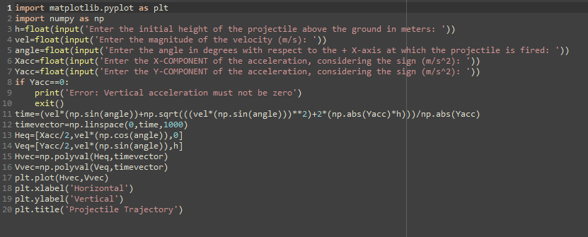

Inputting of data and Outputting of Plot of given data

